Servo motor control using arduino
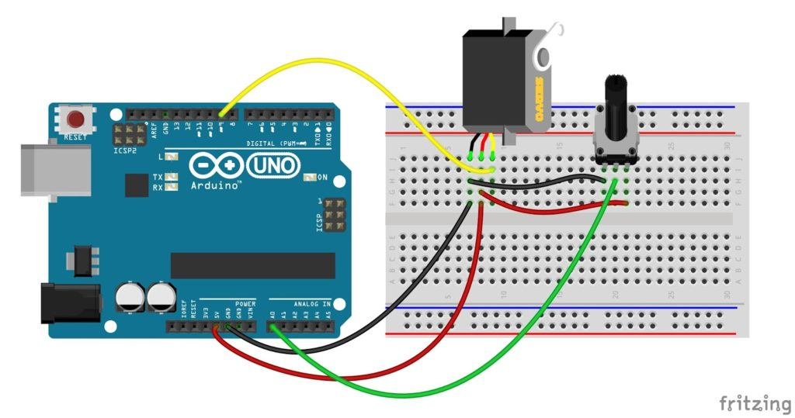

Servo motor

A servo motor is a rotary actuator mostly coupled with a shaft or arm. It has a position control associated with the servo mechanism. It uses a closed-loop control system with error-sensing negative feedback to correct the performance of a mechanism. A servo motor maintains accurate control of angular position and speed of motion of the rotor. The Servos have integrated drive gears and circuit, which precisely control the servo position.
The angular positions of a servo motor are controlled by the pulse width modulation(PWM).
The input pulse train at the control signal will turn the rotor to the desired position. The servo motor expects a control pulse at every 20 milliseconds (ms). The width of each pulse directs the servo to turn the shaft to the corresponding angular positions. That is the duration of the positive pulse in a 20ms total pulse width determines the servo shaft position. For a standard servo, 1ms positive pulse maintains a 0° and a maximum of the 2ms positive pulse will have a position of 180°.
Thus the pulse width between 1ms and 2ms obtains a corresponding position between 0° to 180° angles respectively.
The servo motors are interfaced with the Arduino through a standard three-wire connection.

Power
The power wire mostly has a red colour, which connects to the 5V pin of the Arduino.
The Servo motor requires a considerable amount of power, especially for high power servos. So, for multiple servos or while using servos along with other pins, it is better to power the servo motor separately with an external supply. Because the power at the remaining pins would be interrupted during its operation.

